

**COMMUNICATIONS**

**ALLIANCE LTD**

**Level 12, 75 Miller Street**

**North Sydney**

**NSW 2060 Australia**

**PO Box 444**

**Milsons Point NSW 1565**

**T 61 2 9959 9111**

**F 61 2 9954 6136**

**E info@commsalliance.com.au**

[**www.commsalliance.com.au**](http://www.commsalliance.com.au)

**ABN 56 078 026 507**

Australian

Mobile Telecommunications

Association

ABN 98 065 814 315

First Floor

35 Murray Crescent

Griffith ACT 2603 Australia

PO Box 4309

Manuka ACT 2603 Australia

Ph +61 2 6239 6555

Fax +61 2 6239 6577

Web www.amta.org.au



Mr Carl Toohey

Productivity Commission

By email: PSMB@pc.gov.au

Dear Mr Toohey,

The Australian Mobile Telecommunications Association (AMTA) and Communications Alliance (the Associations) welcome the opportunity to comment on the Productivity Commission’s issues paper on Public Safety Mobile Broadband (PSMB).

The Associations support the Commonwealth’s initiative in undertaking a rigorous analysis to determine the most efficient, effective and economical means of developing a PSMB capability.

The needs and requirements of Public Safety Agencies (PSAs) must steer the overall consideration of the most efficient, effective and economical way of delivering a national PSMB capability. The telecommunications industry has a long history of working co-operatively with public safety agencies. Our members work in partnership with them on a daily basis as well as in times of emergency.

Industry members are keen to work with PSAs and the Productivity Commission to ensure the recommendations from the report lead to the delivery of an efficient and effective PSMB capability for Australia.

Mobile technology has continued to advance since Government first considered a PSMB capability for Australia. Industry believes that PSAs should have access to the best technology the market has to offer. The Associations support the alignment of Australia’s PSMB capability with international standards such as 3GPP. The Australian market is small and we are a technology-taker so it would be unwise not to leverage from developments in other markets and create interoperability where possible. It is also important to ensure interoperability across Australian jurisdictions and agencies.

Mobile networks are expensive to build, operate and maintain. The Associations strongly suggest that any PSMB capability should leverage off existing commercial networks (including the NBN) and associated infrastructure. Unnecessary duplication of infrastructure should be avoided. Industry members have well-established policies and processes in place to enable the sharing of physical infrastructure via the Mobile Carriers Forum (MCF) and similar commercial sharing arrangements should be considered in the design of any PSMB capability.

Spectrum is a finite resource. PSMB requirements will necessarily include “business as usual” needs as well as the need to cater for temporary spikes in capacity or coverage due to special events, emergencies (which can be localised or more wide-ranging) and natural disasters. This suggests that spectrum needs should be considered and planned carefully and that potential sharing arrangements where PSMB use can be given priority should be considered so that spectrum is always allocated to its highest value use.

The Associations look forward to continued participation the Commission’s review process.

Yours sincerely,

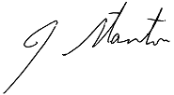

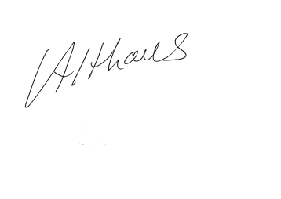

Chris Althaus John Stanton

**AMTA CEO Communications Alliance CEO**